**3 Times Table**

Task 1-

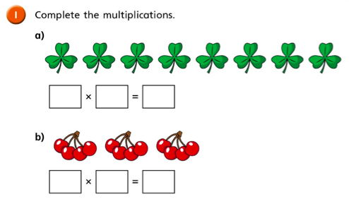

Write your answer underneath -

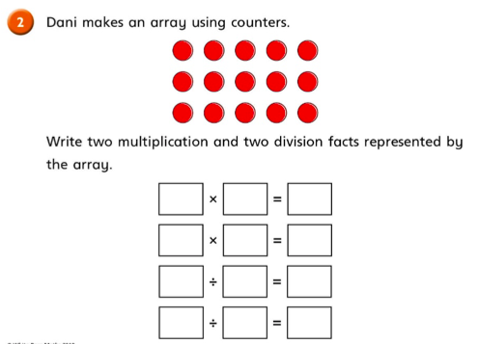

Write your answer underneath -

Task 2 –

Complete the number sentences. Type your answers in for each question.

1. 6 x 3 = 18

2. 3 x = 27

3. 11 x ? = 33

4. 5 x ? = 15

5. 12 x 3 =

6. ? x 3 = 0

7. 2 x 3 =

8. 4 x 3 =

9. 8 x 3 =

10. 6 = 3 x ?

11. 12 = 3 x ?

12. 18 = 3 x ?