**3 Times Table**

Task 1 - Can you fill in the missing gaps in the 3 times table ? Hint you might have to go past 3 x 12.

3, ? , 9, ?, ? , ? , ? , ? , ?, ?, ?, ? , ? , ? , ? , ?

Task 2 - Can you fill in the missing gaps in the 3 times table ?

You are counting forward for this task.

| 30 |  | 36 |  |  |  |
| --- | --- | --- | --- | --- | --- |

You are counting backwards in this task.

| 39 | 36 |  |  | 27 |  |  |
| --- | --- | --- | --- | --- | --- | --- |

Task 3 - Fill in the missing gaps :

1. **3 x 4 = ?**
2. **9 = 3 x ?**
3. **21 = ? x ?**
4. **5 x 3 = ?**
5. **10 x 3 =**
6. **33 = 11 x ?**
7. **12 x ? = 36**
8. **0 x 3 = ?**

**Challenge Questions**

**Task - Can you solve the problems questions all about the 3 times tables ?**

**1. Can you work out which statement is correct, relating to the pea pod picture ?**

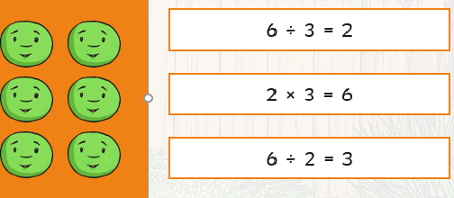

**Explain your reasoning below :**

**2. Sam buys 36 toy dinosaurs for Golden Time for Year 3. There are 12 children in the class.**

**How many toy dinosaurs does each child receive?**

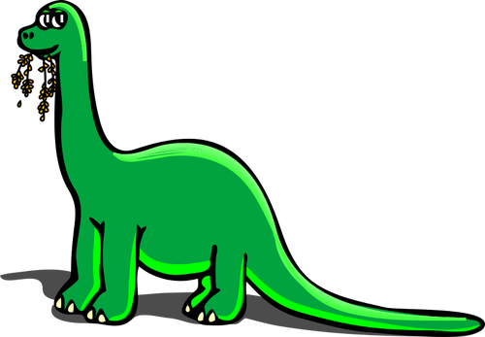

**Show your working out below :**