**All about Winter**

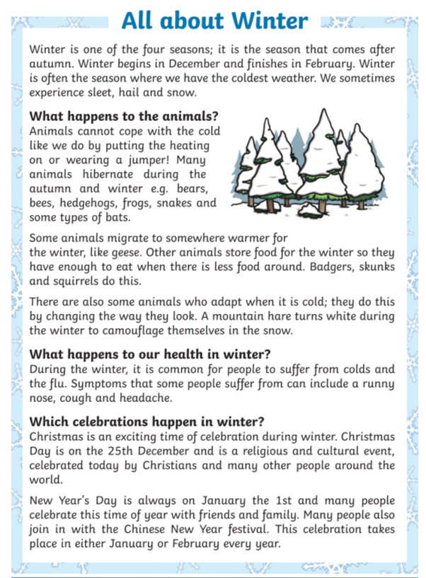**Read the text below and then answer the questions.**

**All about Winter – Questions**

1. Name two types of weather we can experience in winter.

__________________ and ____________________

2. When does winter begin and end?

___________________________________________

3. Which season does winter come after?

________________

4. Name an animal that changes colour in winter and the colour it turns.

______________________________________________

5. What do some animals do so that they have enough to eat when there is less food?

_______________________________________________________________________________________________________________________________________________________________

6. What can happen to our health in winter?

_______________________________________________________________________________________________________________________________________________________________

7. Who celebrates Christmas?

__________________________________________________________________________________________________________

8. What do many people do at New Year?

__________________________________________________________________________________________________________

9. Which festival takes place in either January or February every year?

__________________________________________________________________________________________________________