**Literacy Task Leon and the Place Between**–

Task - Create a character description about Leon.

You must include:

- What he is wearing.

- His likes and dislikes.

- You must include one simile in your description.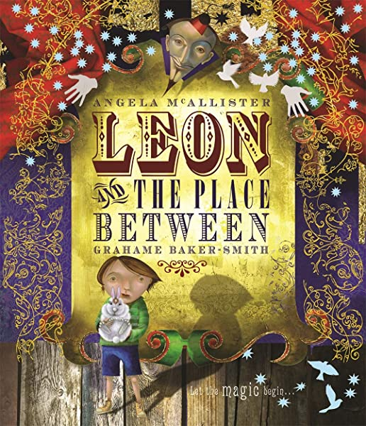

|  |  |
| --- | --- |
|  |  |

Please write your character description underneath.