Challenge 1 - The Mersey Ferry ArtWork

Task -Read the interesting facts below.
Then can you create your own design of the Mersey Ferry ?
There is a picture below to help you with your design.

‘Snowdrop’ the Dazzle Ferry was created by Sir Peter Blake. It has many different patterns painted on the ferry. How many patterns can you spot ?

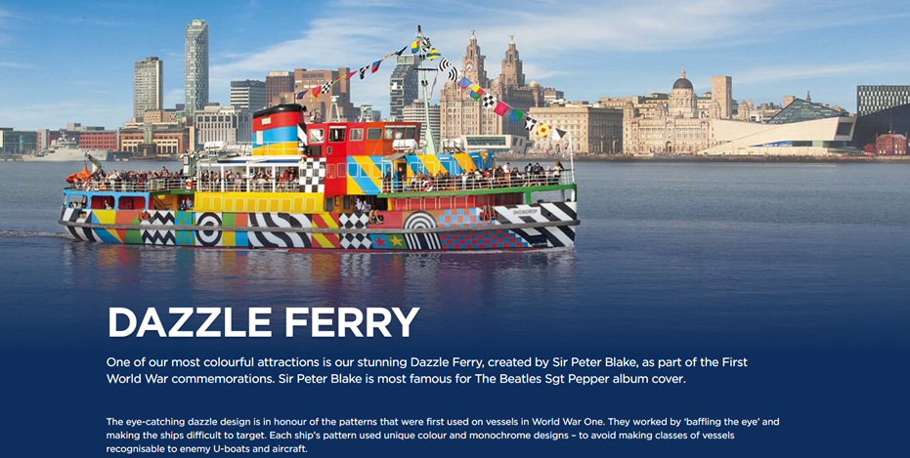

Transport on the Mersey
The ferries that cross the River Mersey are Liverpool’s, perhaps the world’s – most famous river crossing. Monks from Birkenhead Priory founded the first Mersey ferry service in the 13th century. The Domesday Book (1086) records later services between Seacombe and the Pool. In 1317 a royal license gave permission to begin ferrying passengers from Woodside. Thus were created the three points between which most Mersey ferries travel to this day.
Task - Can you create your own design of the ‘Snowdrop’ Dazzle Ferry ?
